**Assignment-3**

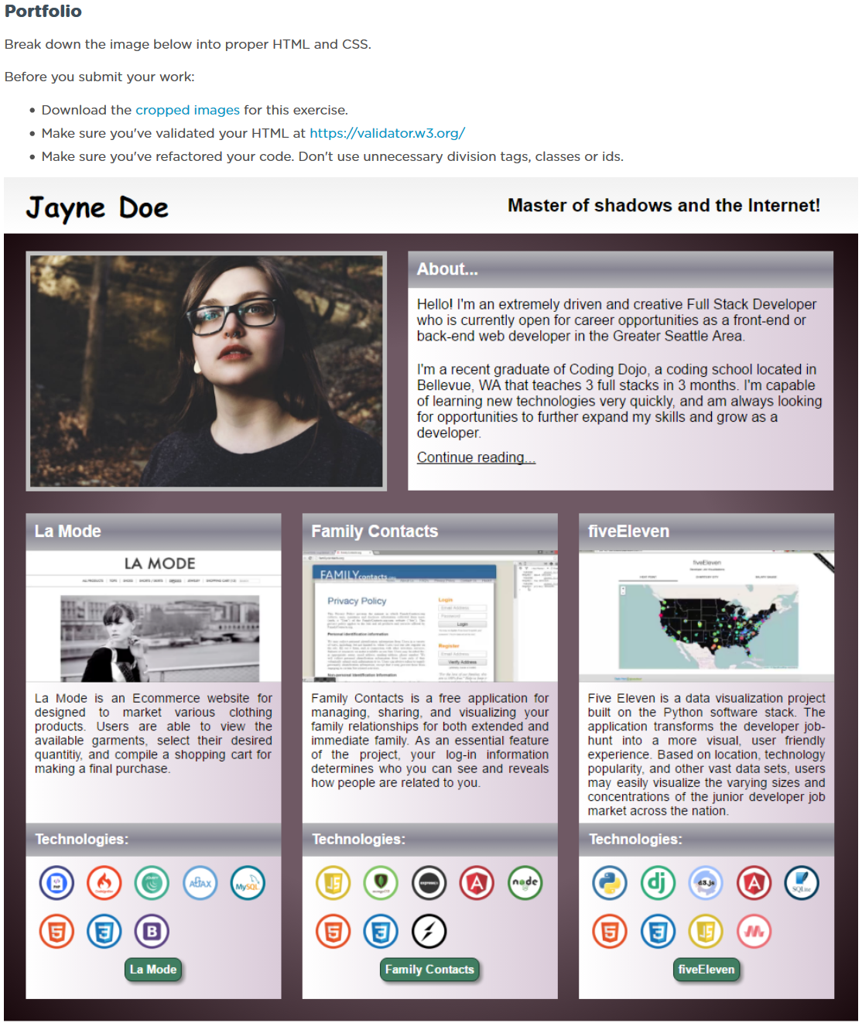

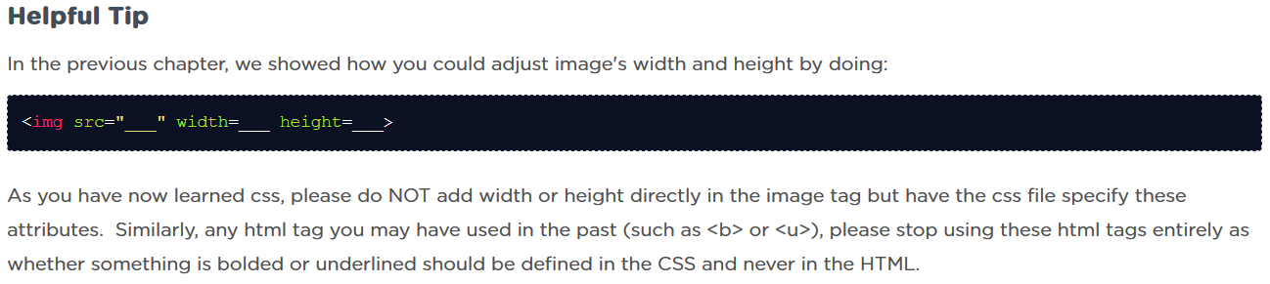

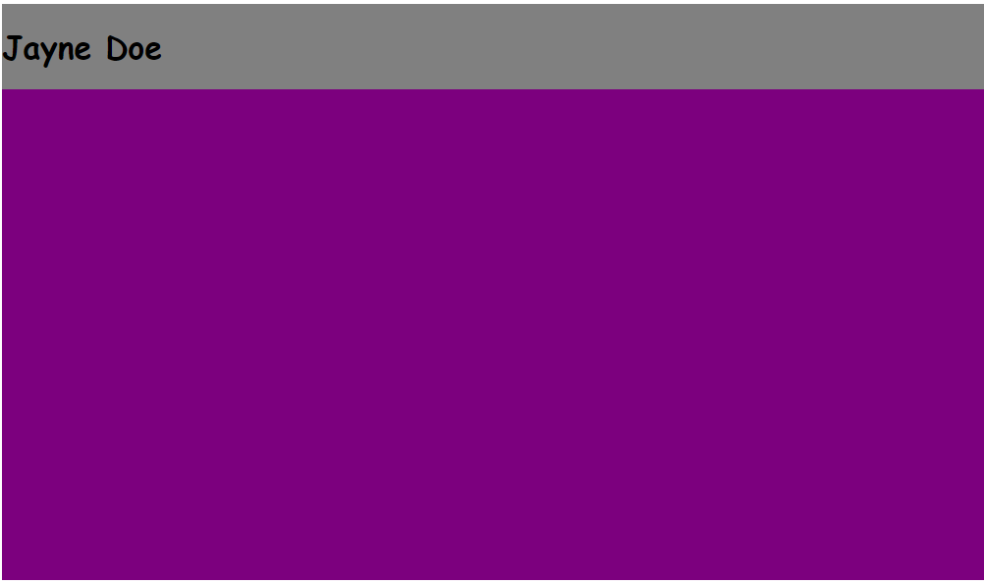

Commit: Main containers: Gray and purple (without gradients)

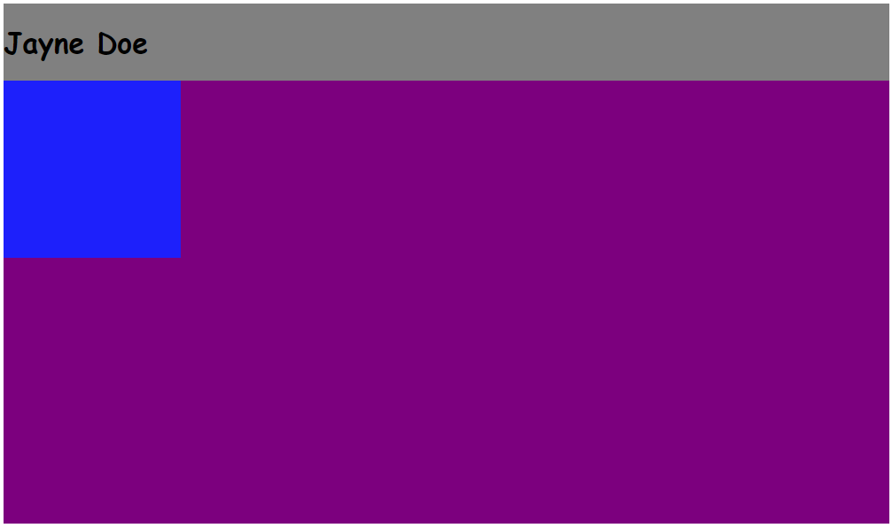

Commit: Floating box (upper left corner)

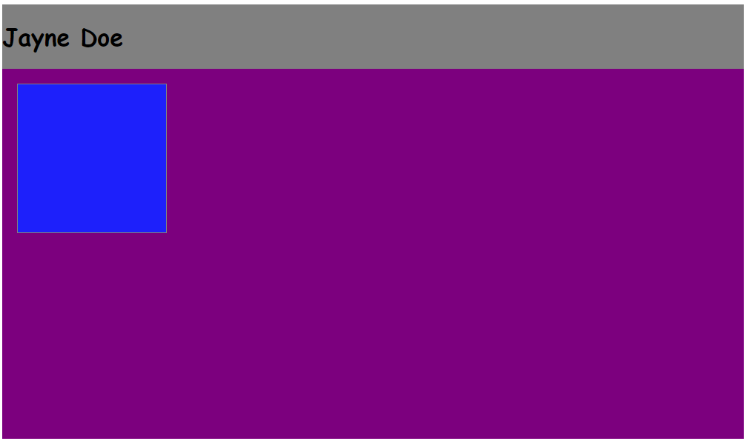

**Local**: D:\dev\bootcamp\01_Web-Fundamentals\02_CSS\02_portfolio

**Repo**: bootcamp

**Branch**: Master

**Commit**: Border and margin of upper left floating block.

**Note**:

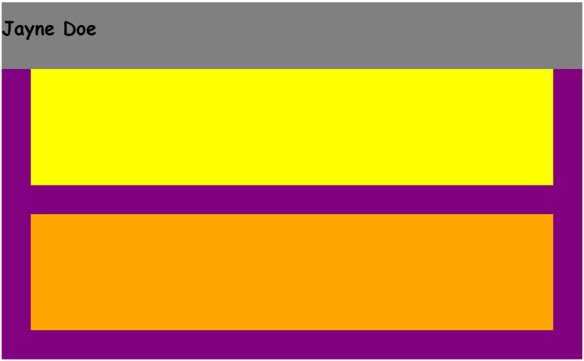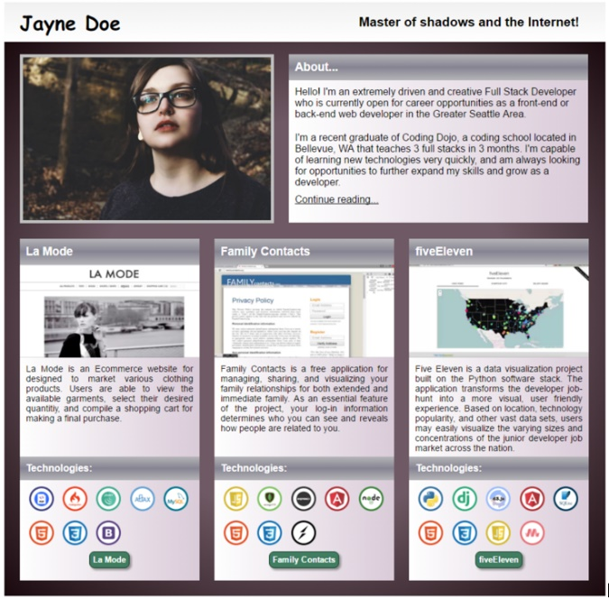

**Local**: C:\dev\CSS-3_portfolio

**Repo**: CSS-3_portfolio

**Branch**: Master

**Commit**: Added two rows.

**Note**:

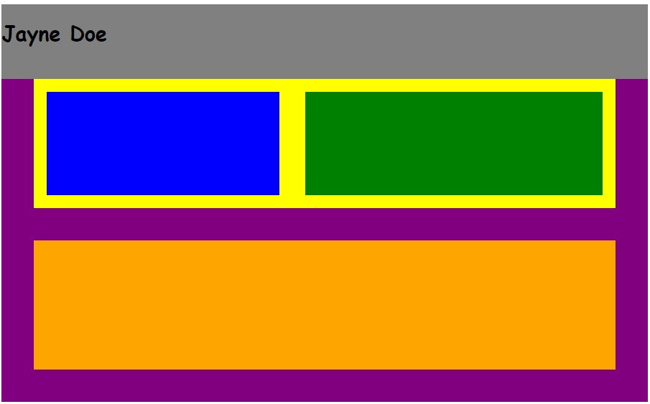

**Local**: C:\dev\CSS-3_portfolio

**Repo**: CSS-3_portfolio

**Branch**: Master

**Commit**: Added two blocks inside the top row.

**TODO**: Add rows inside bottom cols.

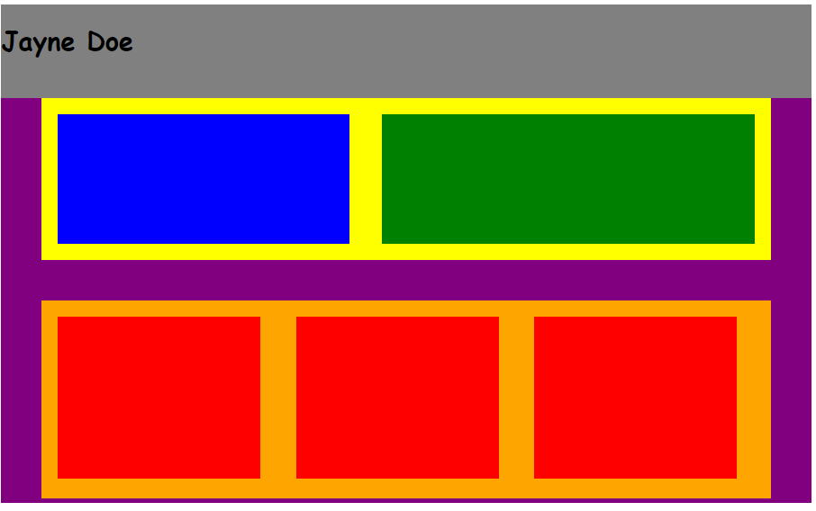

**Local**: C:\dev\CSS-3_portfolio

**Repo**: CSS-3_portfolio

**Branch**: Master

**Commit**: Add three cols inside row-2.

**TODO**: Add in two rows in each column in bottom row.

**Then**: Add in two rows inside these for the top grey bordertext

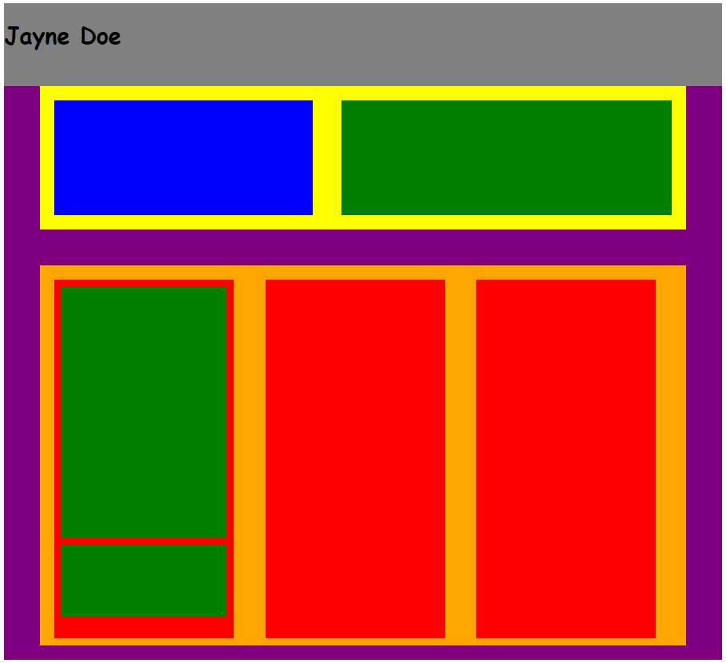

**Local**: C:\dev\CSS-3_portfolio

**Repo**: CSS-3_portfolio

**Branch**: Master

**Commit**: Add in two rows in each column in bottom row.

**TODO**: Add in two rows inside these for the top grey bordertext

**Then**: Add text to these newly added boxes.

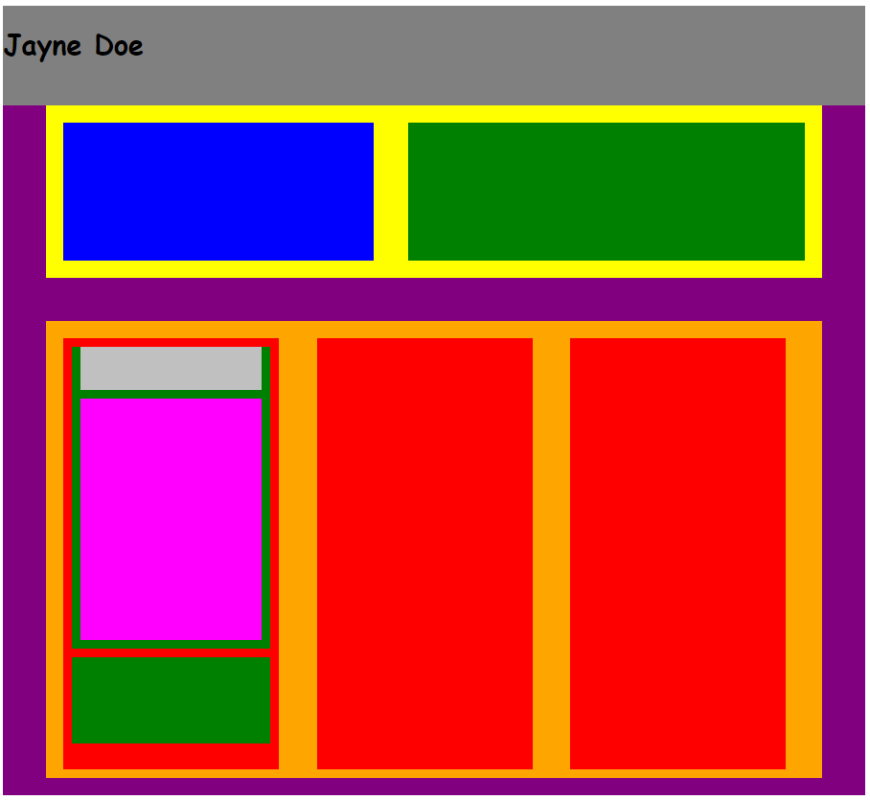

**Local**: C:\dev\CSS-3_portfolio

**Repo**: CSS-3_portfolio

**Branch**: Master

**Commit**: Add in two rows inside these for the top grey bordertext

**TODO**: Add text to these newly added boxes.

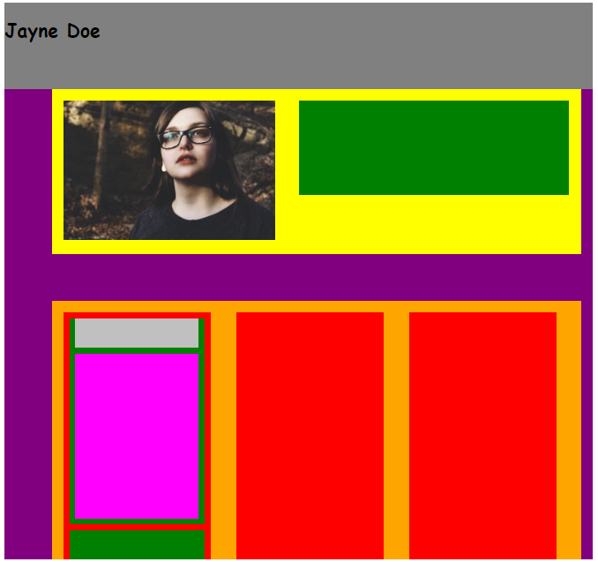

**Local**: C:\dev\CSS-3_portfolio

**Repo**: CSS-3_portfolio

**Branch**: Master

**Commit**: Added image

**TODO**: Add text to top right green box.

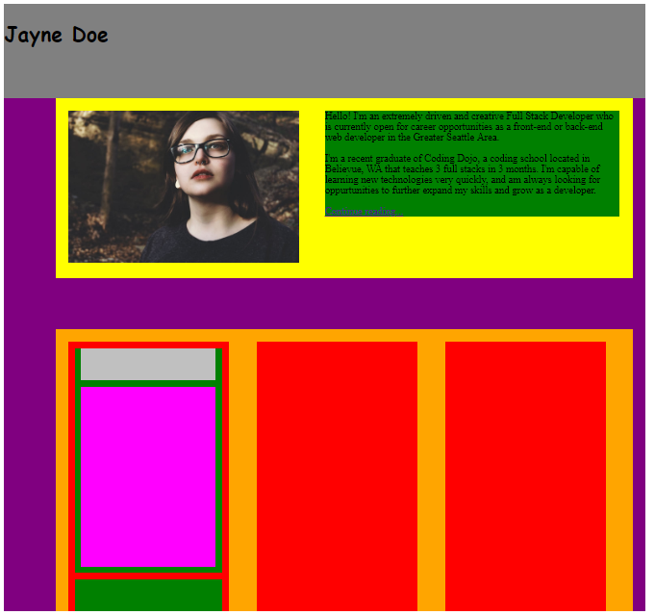

**Local**: C:\dev\CSS-3_portfolio

**Repo**: CSS-3_portfolio

**Branch**: Master

**Commit**: Added text to top right green box.

**TODO**: Add two boxes to green box, similar to as done in a previous step.

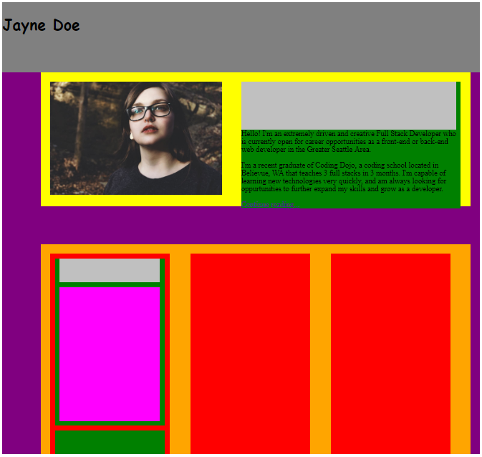

**Local**: C:\dev\CSS-3_portfolio

**Repo**: CSS-3_portfolio

**Branch**: Master

**Commit**: Added grey sub-box in the upper right box and moved the text below.

**TODO**: Change size of sub-boxes in the newly added green box.

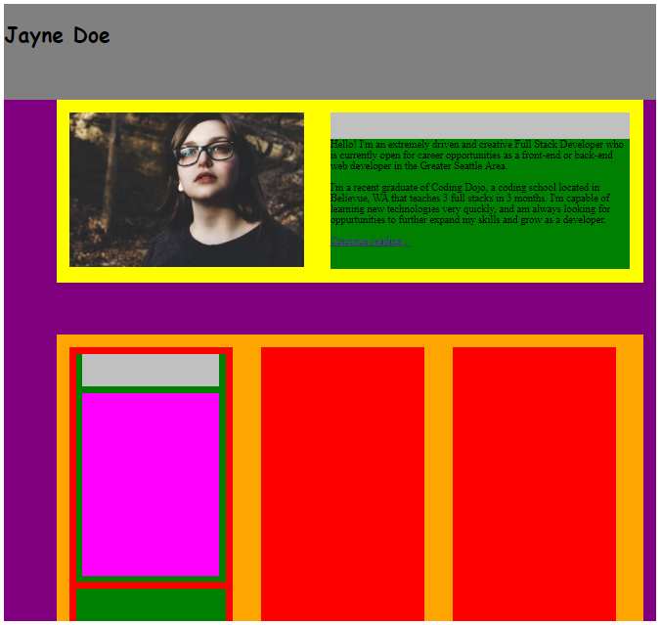

**Local**: C:\dev\CSS-3_portfolio

**Repo**: CSS-3_portfolio

**Branch**: Master

**Commit**: Got size of boxes in upper right box approximately where they ultimately need to be.

**TODO**: Add text to the grey strip in the upper right box.

**Then**: If works, then repeat process for the columns in the

second row.

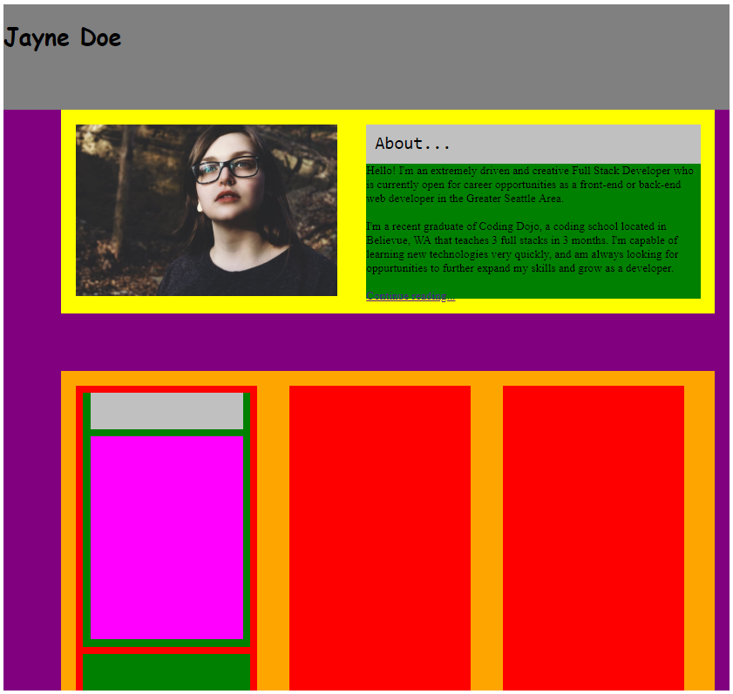

**Local**: C:\dev\CSS-3_portfolio

**Repo**: CSS-3_portfolio

**Branch**: Master

**Commit**: Added text in header in upper right box (“About…”)

**TODO**:Repeat process for the columns in the second row.

**Local**: C:\dev\CSS-3_portfolio

**Repo**: CSS-3_portfolio

**Branch**: Master

**Commit**: Started over from scratch using the technique of superimposing the spec onto my design.

**TODO**:

* Add top div
* Add upper left image.
* Add upper right div.
* Add in first div below the image.
* Add in next two center divs
* Add in footer div.

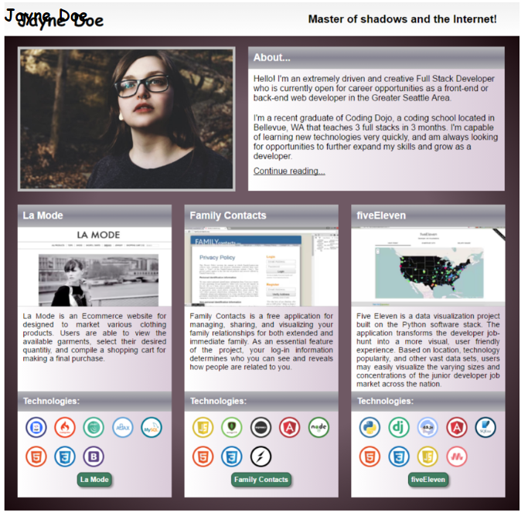

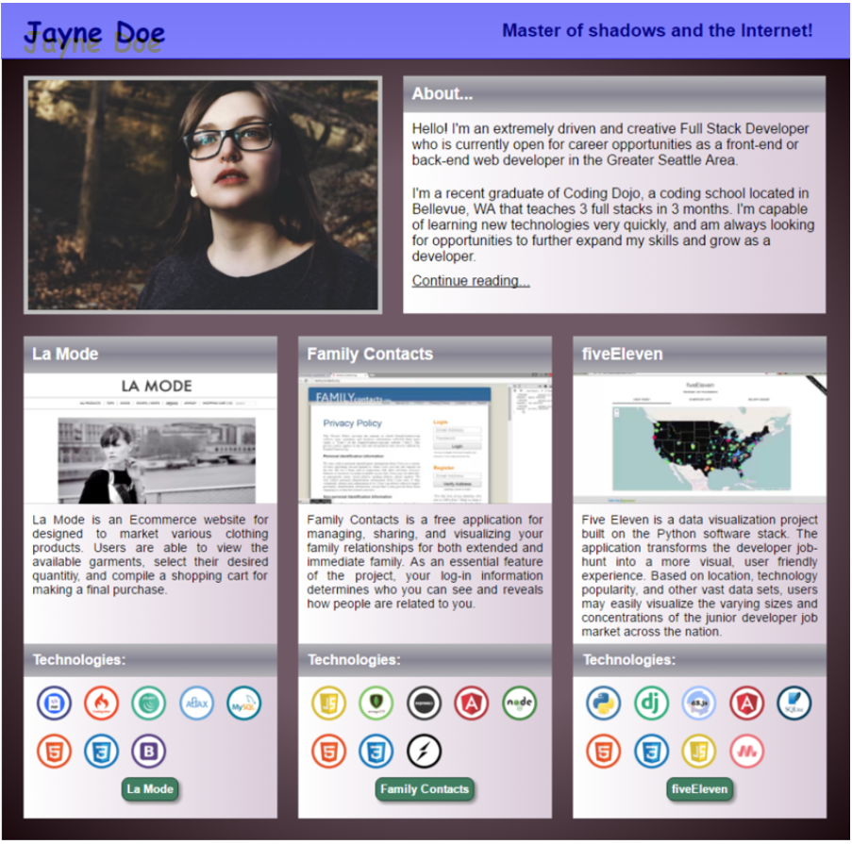

**Local**: C:\dev\CSS-3_portfolio

**Repo**: CSS-3_portfolio

**Branch**: Master

**Commit**: Added top div.

**TODO**:

* ~~Add top div~~
* Add upper left image.
* Add upper right div.
* Add in first div below the image.
* Add in next two center divs
* Add in footer div.

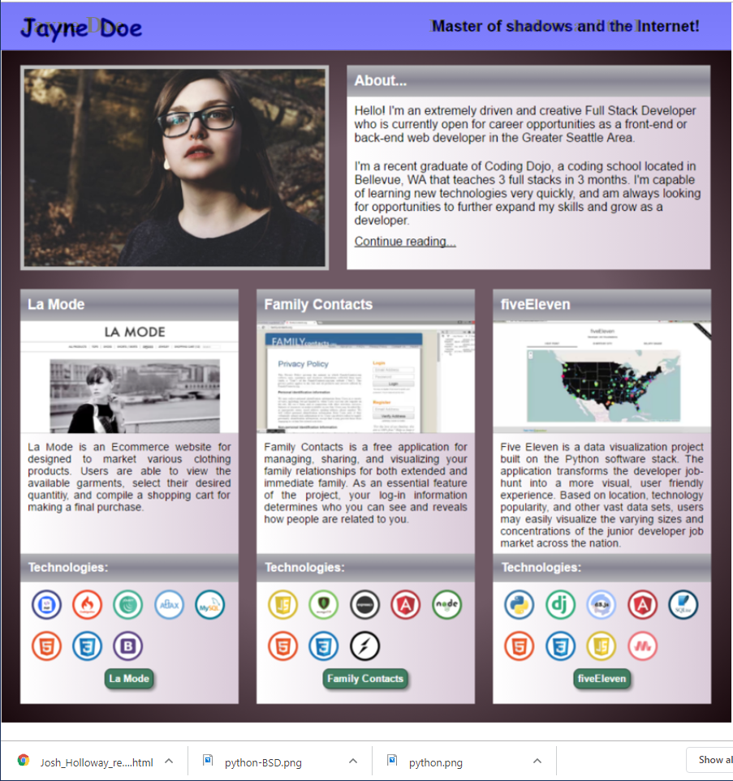

**Local**: C:\dev\CSS-3_portfolio

**Repo**: CSS-3_portfolio

**Branch**: Master

**Commit**: Added upper right text.

**TODO**:

* ~~Add top div~~
* Add upper left image.
* Add upper right div.
* Add in first div below the image.

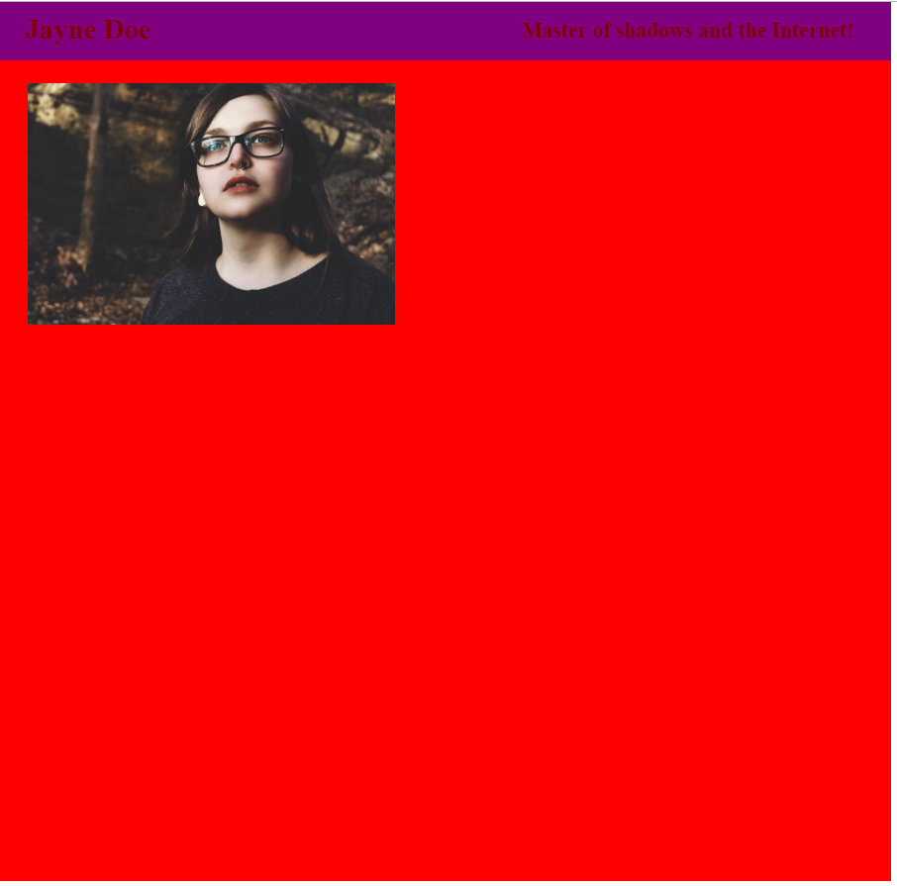

**Local**: C:\dev\CSS-3_portfolio

**Repo**: CSS-3_portfolio

**Branch**: Master

**Commit**: Added top left image.

**TODO**:

* ~~Add top div~~
* ~~Add upper left image.~~
* Add upper right div.
* Add in first div below the image.
* Add in next two center divs
* Add in footer div.

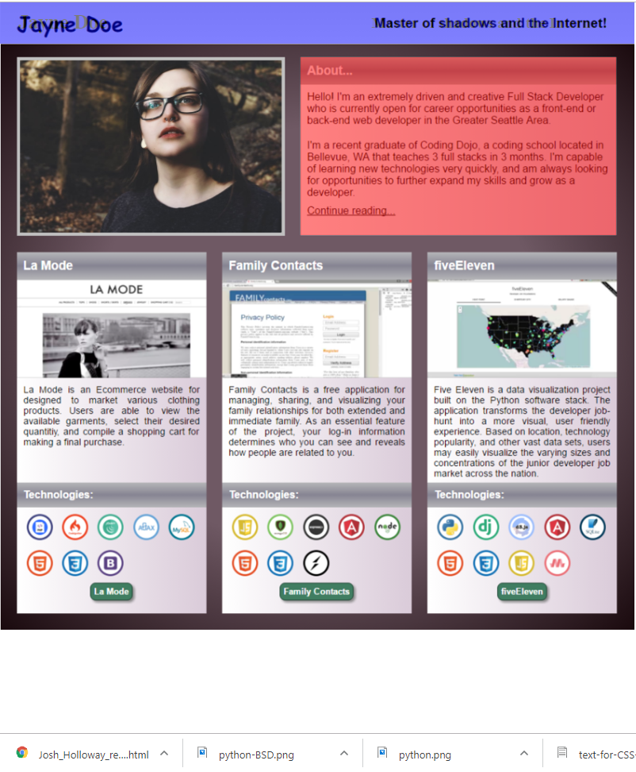

**Local**: C:\dev\CSS-3_portfolio

**Repo**: CSS-3_portfolio

**Branch**: Master

**Commit**: Added upper right box (About…)

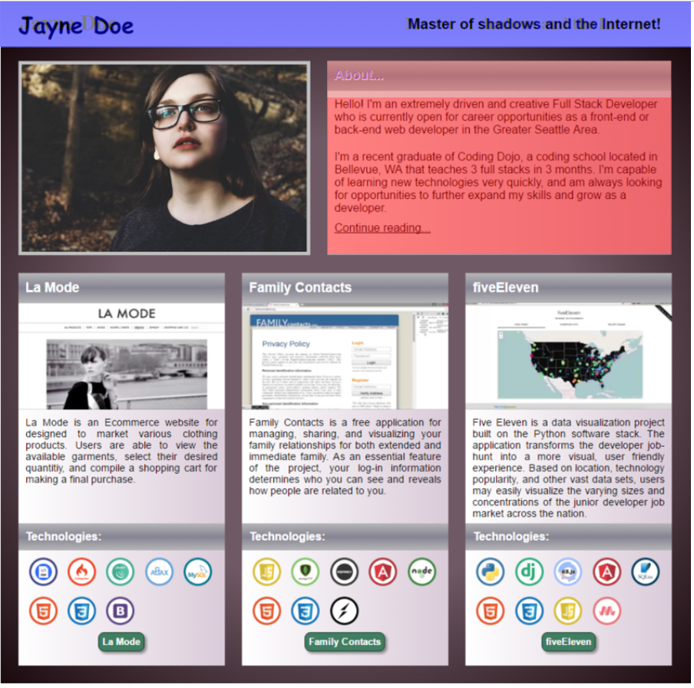

**Local**: C:\dev\CSS-3_portfolio

**Repo**: CSS-3_portfolio

**Branch**: Master

**Commit**: Added title-text in upper right box.

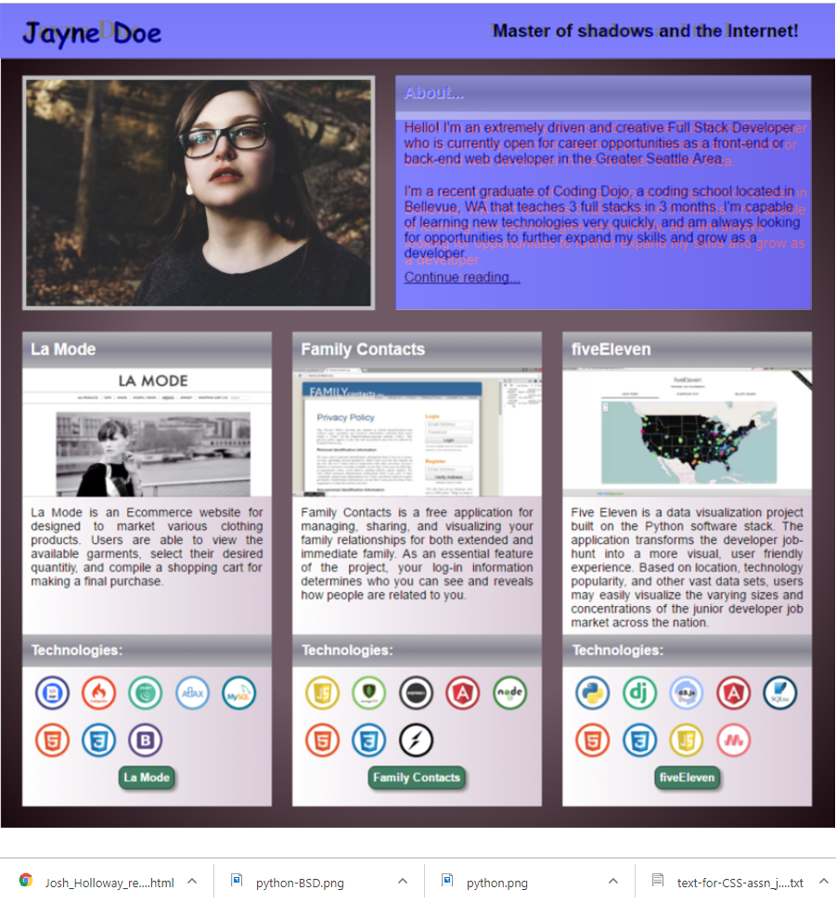

**Local**: C:\dev\CSS-3_portfolio

**Repo**: CSS-3_portfolio

**Branch**: Master

**Commit**: Added body-text in upper right hand corner.

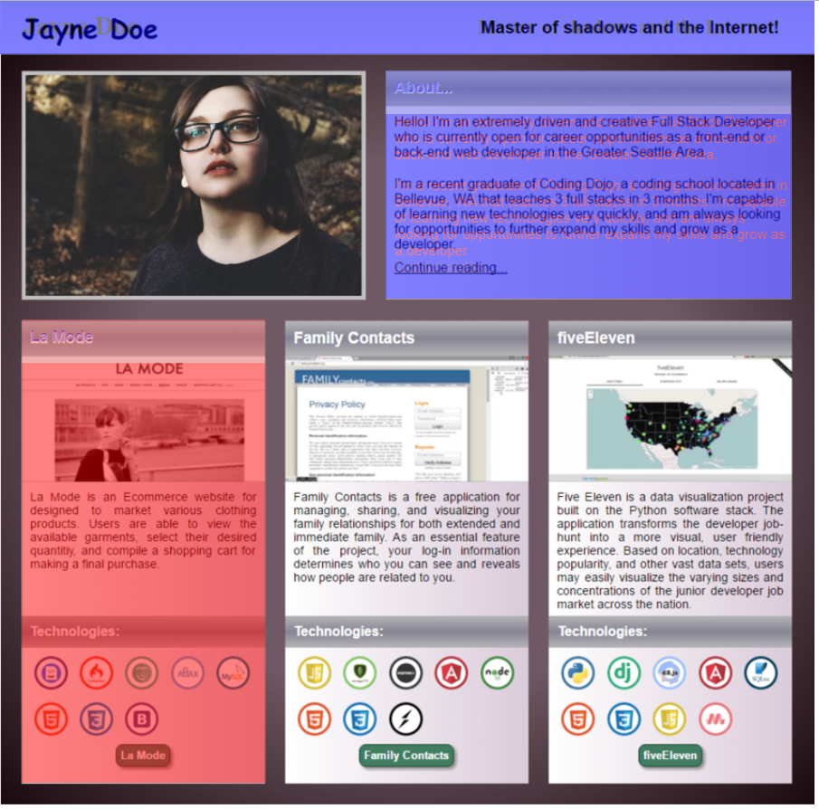

**Local**: C:\dev\CSS-3_portfolio

**Repo**: CSS-3_portfolio

**Branch**: Master

**Commit**: Added left column.

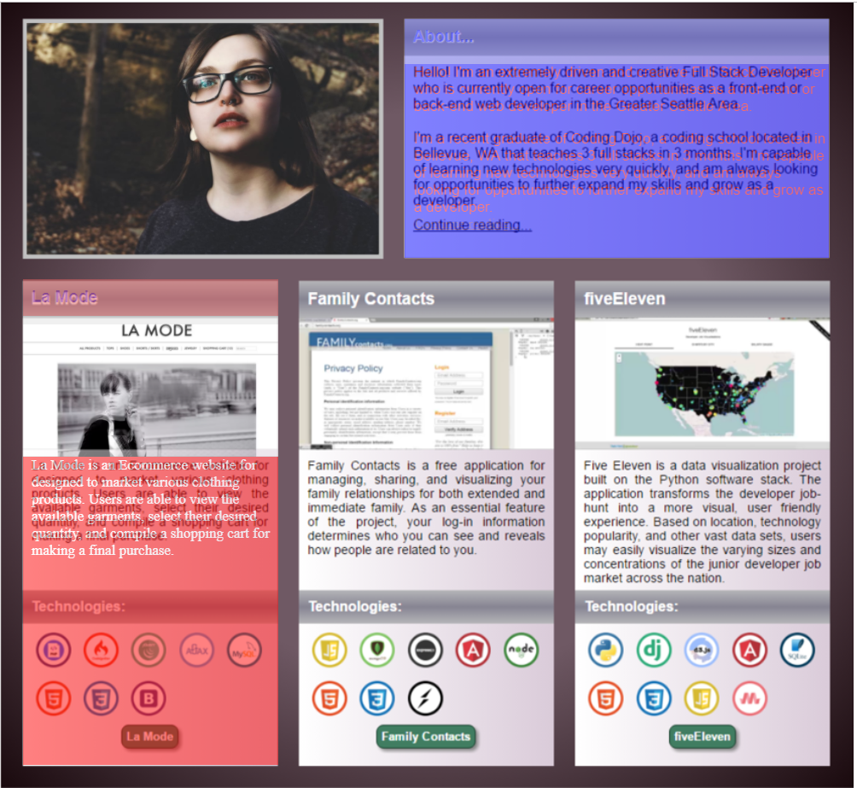

**Local**: C:\dev\CSS-3_portfolio

**Repo**: CSS-3_portfolio

**Branch**: Master

**Commit**: Half way done with left most column.

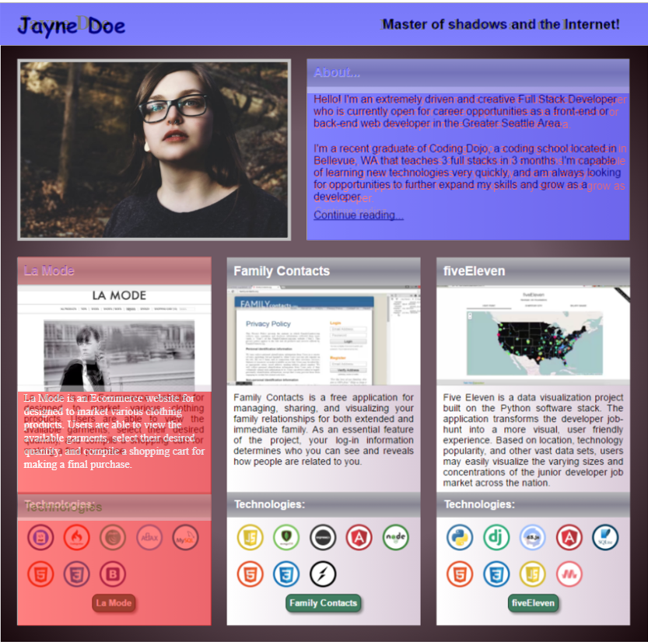

**Local**: C:\dev\CSS-3_portfolio

**Repo**: CSS-3_portfolio

**Branch**: Master

**Commit**: Added Technologies to left most column.

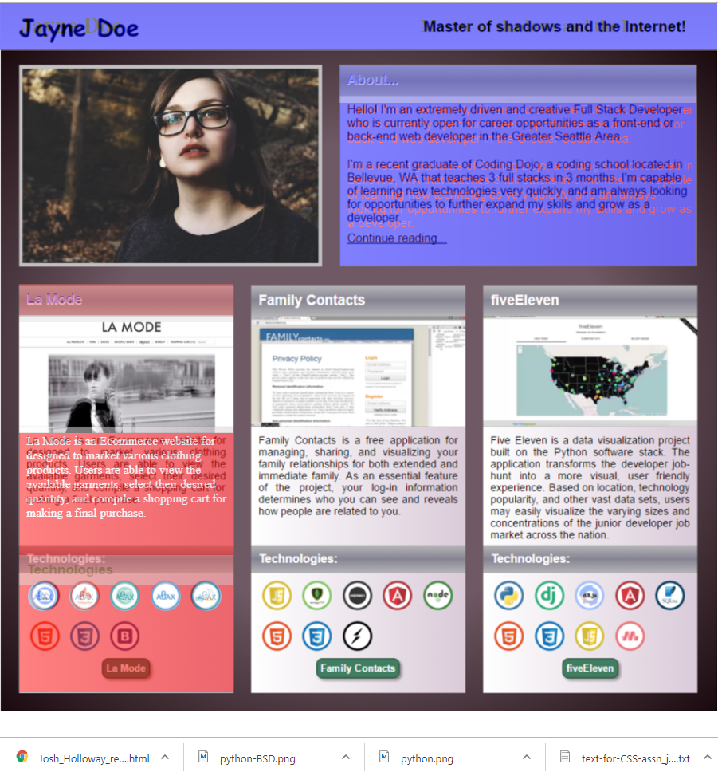

**Local**: C:\dev\CSS-3_portfolio

**Repo**: CSS-3_portfolio

**Branch**: Master

**Commit**: Added first row of tech images

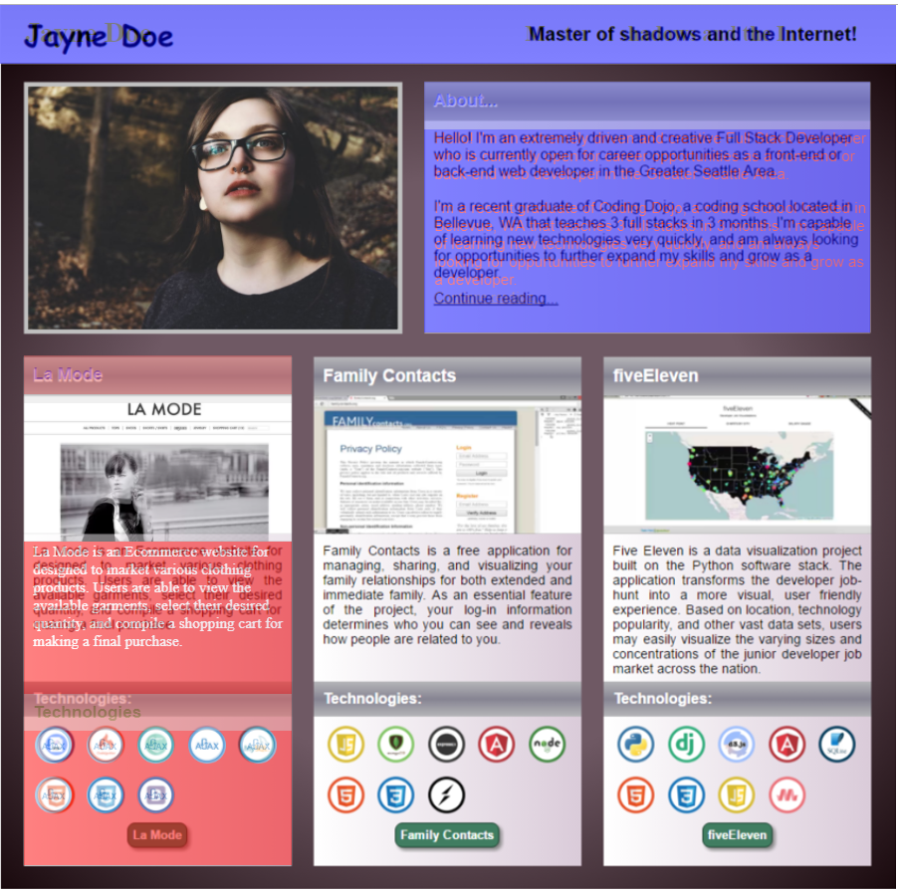

**Local**: C:\dev\CSS-3_portfolio

**Repo**: CSS-3_portfolio

**Branch**: Master

**Commit**: Added second row of tech images

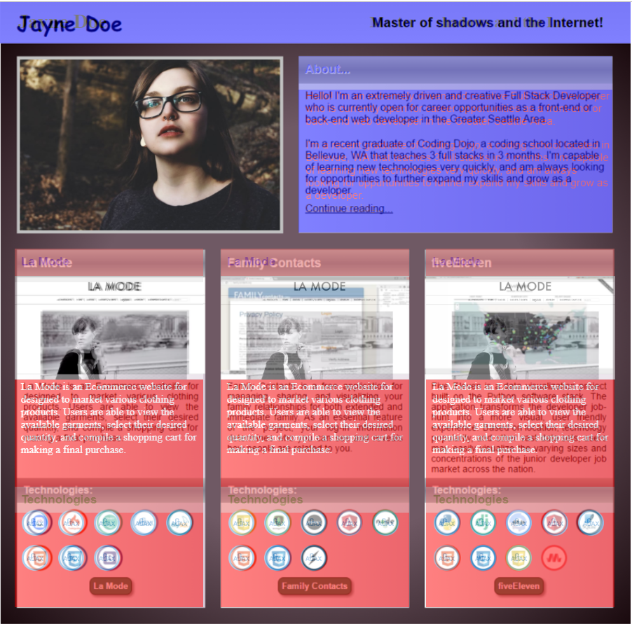

**Local**: C:\dev\CSS-3_portfolio

**Repo**: CSS-3_portfolio

**Branch**: Master

**Commit**: Added three columns.

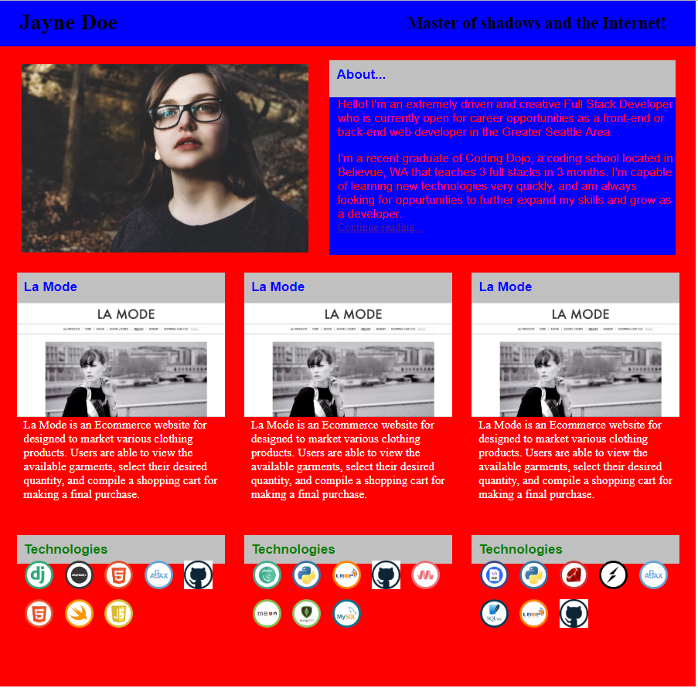

**Local**: C:\dev\CSS-3_portfolio

**Repo**: CSS-3_portfolio

**Branch**: Master

**Commit**: Removed transparency and added in all technology images.

**TODO**:

* Change background color to purple gradient
* Add title gradients
* Add border to image
* Change font of the Name
* Change images in columns
* Add green image at bottom of each column

**Local**: C:\dev\CSS-3_portfolio

**Repo**: CSS-3_portfolio

**Branch**: Master

**Commit**: Started again from scratch.

**NOTE**: Old is located here on workstation:

D:\dev\CSS-3_portfolio_old

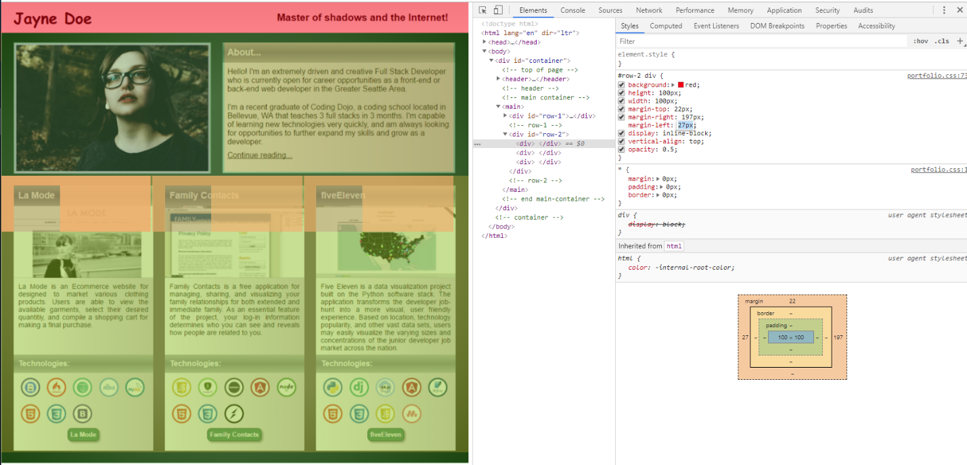

**Local**: C:\dev\CSS-3_portfolio

**Repo**: CSS-3_portfolio

**Branch**: Master

**Commit**: Finished structure of top row and left most column.

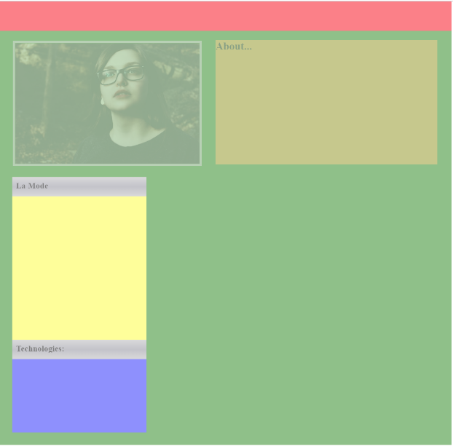

**Local**: C:\dev\CSS-3_portfolio

**Repo**: CSS-3_portfolio

**Branch**: Master

**Commit**: Finished col complete.

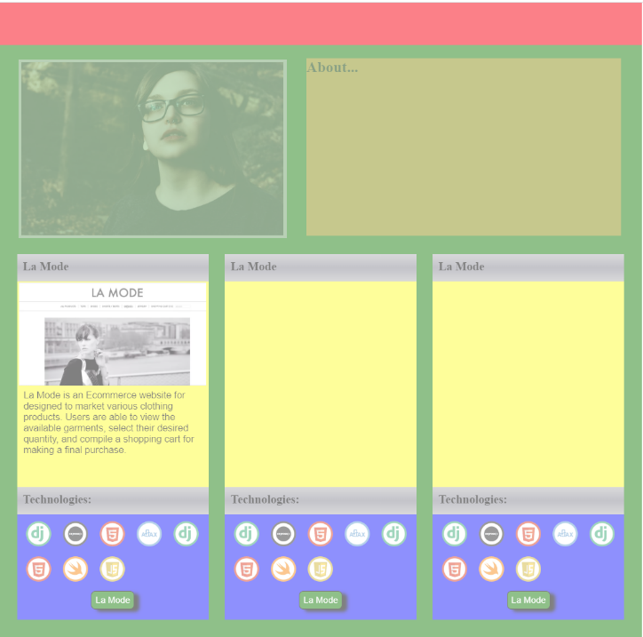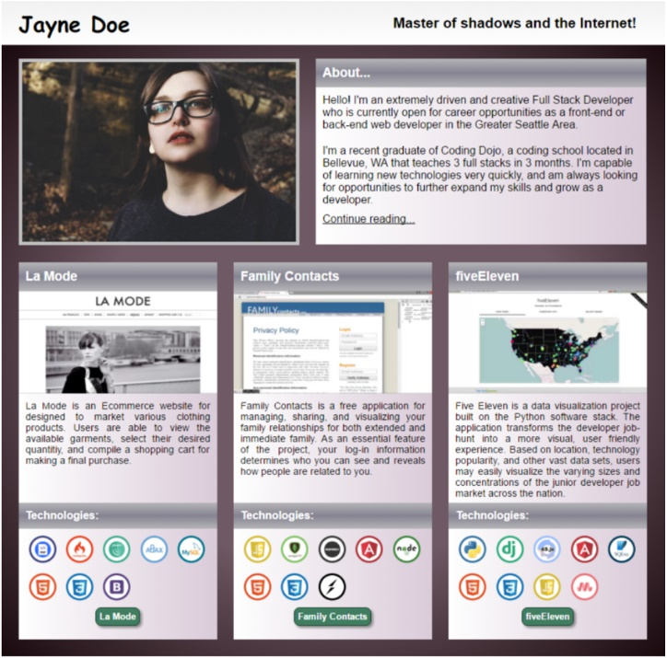

**Local**: C:\dev\CSS-3_portfolio

**Repo**: CSS-3_portfolio

**Branch**: Master

**Commit**: Added background gradient

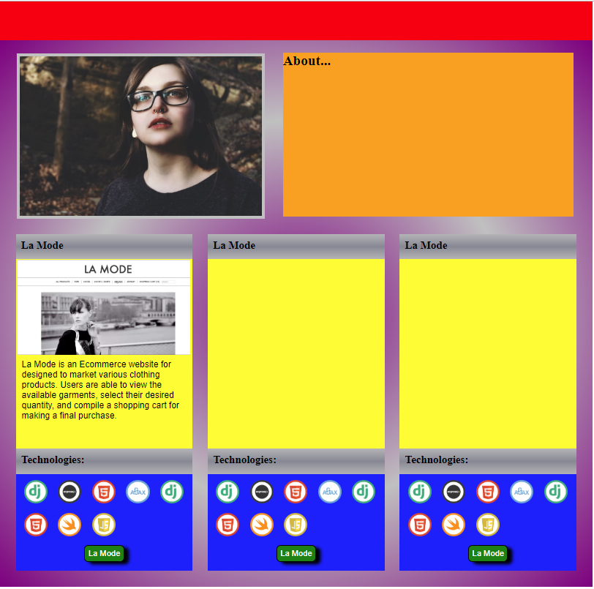

**Local**: C:\dev\CSS-3_portfolio

**Repo**: CSS-3_portfolio

**Branch**: Master

**Commit**: Added correct text to all columns.

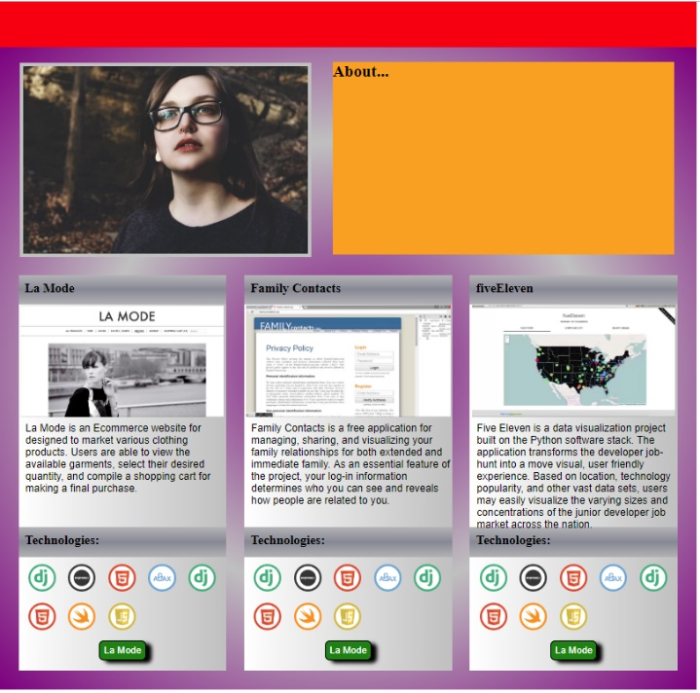 

**TODO**:

* Columns
  + ~~Change title font and color~~
  + Align padding
  + Adjust height to fit in right most text
* Title bar
  + ~~Silver color~~
  + Name (h1)
  + Master of shadows
* “About”-box:
  + ~~Title Padding~~
  + ~~Title gradient~~
  + Background gradient
  + Link

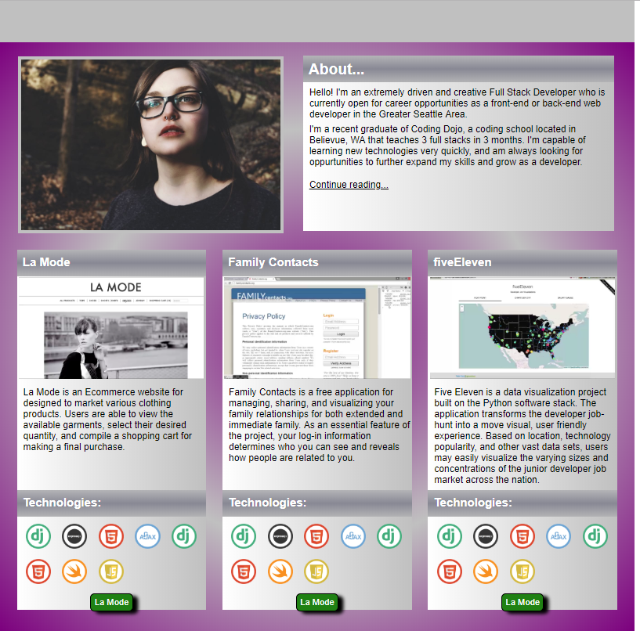

**Local**: C:\dev\CSS-3_portfolio

**Repo**: CSS-3_portfolio

**Branch**: Master

**Commit**: Adjusted height of main container

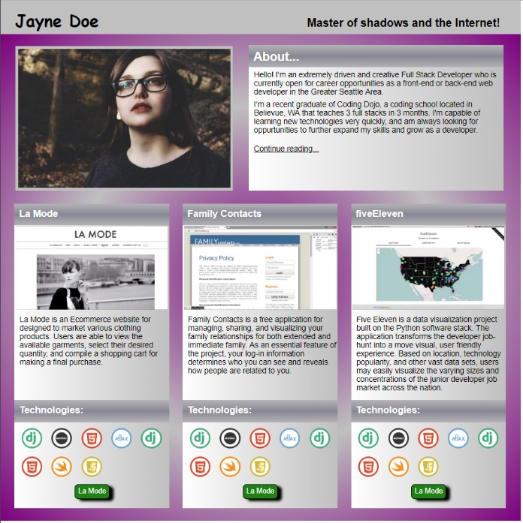

**Local**: C:\dev\CSS-3_portfolio

**Repo**: CSS-3_portfolio

**Branch**: Master

**Commit**: v1-complete